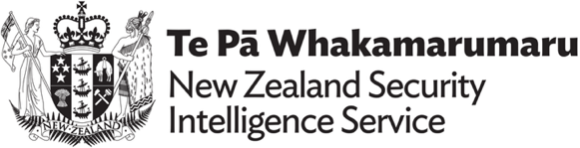
Case studies from New Zealand Security Intelligence Service
These case studies are from New Zealand’s Security Threat Environment | New Zealand Security Intelligence Service. In these case studies “foreign state” means any country other than New Zealand. This term is used to refer to countries outside of New Zealand.
The New Zealand Security Intelligence Service (NZSIS) defines foreign interference as an act by a foreign state, often acting through a proxy, which is intended to influence, disrupt or subvert New Zealand’s national interests by deceptive, corruptive or coercive means. Normal diplomatic activity, lobbying and other genuine, overt efforts to gain influence are not considered interference.

Case study 1
In 2023, a foreign state used a New Zealand contact to pressure a local council by offering to help fund a community event if they agreed to restrict the participation of a particular religious group. The foreign state wanted it known that the group is banned in their country and carries out activities ‘against the will’ of the state’s diaspora.

Case study 2
The NZSIS is aware of several diplomats representing a foreign state who maintain relationships with a number of New Zealand student groups associated with that state’s diaspora population. The diplomats have used this access to influence group memberships in an effort to ensure that those elected to leadership positions are politically loyal to the foreign state. They have chosen to obscure their relationship with the student groups to avoid accusations of interference in academic society. Conducting themselves in this way is an example of foreign interference. They are seeking to control how these groups and their members view the state and aim to identify dissidents.

Case study 3
A small number of foreign states collect information on specific communities in New Zealand. Often these states will use community members to monitor people the foreign state views as dissidents in New Zealand and gather personal details about them. This information can be used to conduct retaliatory action such as cancelling visas or targeting family members still living in the foreign country. In 2023, a foreign state denied the visa application of a New Zealand person trying to visit family in the country due to their association with a community group the foreign state did not like.

